A PROJECT REPORT ON
Obstacle detection using Ir sensor
Submitted in accordance with the curriculum requirements for seventh semester of the degree course in

BACHELOR OF TECHNOLOGY

SUBMITTED BY
C. NAGENDRA (14691A04B3)
B.NAGA RAMMOHAN (14691A04B1)
N. KAILASH PREETHAM (14691A0476)
D. NAVAKISHORE (14691A04B6)
Under the guidance of
Mr. M. Jagadeesh Babu, M.E., (Ph.D.) Asst.Professor
DEPARTMENT OF ELECTRONICS AND COMMUNICATION ENGINEERING

MADANAPALLE INSTITUTE OF TECHNOLOGY & SCIENCE
(UGC-Autonomous)
(Approved by AICTE & Affiliated to JNTUA, Anantapuram)
ANGALLU, MADANAPALLE-517325

MADANAPALLE INSTITUTE OF TECHNOLOGY & SCIENCE
(UGC-Autonomous)
(Approved by AICTE & Affiliated to JNTUA, Anantapuram)
ANGALLU, MADANAPALLE-517325

CERTIFICATE
This is to certify that the thesis / dissertation /Seminar entitled Obstacle Detection using IR Sensor that is being submitted by C. Nagendra, D. Navakishore, B. Naga Rammohan, N. Kailash Preethamduring seventh semester in partial fulfilment for the award of B.Tech to the Jawaharlal Nehru Technological University is a record of bonafide work carried out by them under our guidance and supervision. The results embodied in this thesis have not been submitted to any other University or Institution for the award of any degree or diploma.

Signature of Supervisor/Guide Signature of the Head of the Department

Mr. M. Jagadeesh Babu Dr. S. Rajasekaran
M.E., (Ph.D.) Asst.Professor Ph.D. ,Sr.Assistant professor & Head of ECE Dept.

ACKNOWLDEGEMENT
We wish to express our deep sense of gratitude to Mr. M. Jagadeesh Babu, M.E., (Ph.D.), Asst. Professor In Electronics and Communication Engineering department in MADANAPALLE INSTITUTE OF TECHNOLOGY AND SCIENCE(UGC- AUTONOMUS) angallu, Madanapalle, Chittoor. Who laid the time bond for the successful completion of this project. They challenged our thoughts and extended timely suggestions for which we are deeply indebted to them.
We are also expressing our sincere thanks to Dr.S.Rajasekaran, Ass.Professor & HOD(ECE),for their esteemed support provided.
Also we would like to express our gratitude to faculty members of Electronics and Communication Engineering department, Electrical and Electronics Engineering and those who are directly or indirectly helped us in successful completion of our project.

ABSTRACT
An embedded system is a combinationofsoftware and hardware which is designed foronespecific application in a time domainconstraint.Now-a-days the meaning of the embeddedsystemwas changed because, it was not designed onlyforone specific application but, many applicationscanrun with a single embedded system. Thebestexample of an embedded system is a mobilephonewhich performs the communication, along withthecommunication one can surf the internet, accessthesocial network sites, play the games and evenglobalpositioning system is deployed into such a small device.
Infrared sensors find numerousapplications in electronic systems. Commonlyusedasobstacledetector,theiroutputisusedindigitalform (high & low logic) by employing acomparator.Thistopicexplainsawaytousethesensor’s output in its original analog form.Thus,along with detecting an obstacle, its exactdistancecan also be obtained. This is achieved byprocessingthe output of IR sensor through an ADC. TheADCis calibrated to get almost accuratedistancemeasurement.

The measured distance is also displayedonan LCD screen. The ADC and LCD areinterfacedwith PIC microcontroller toperformthese operations. The major drawback of IRbasedsensors is their capability of detectingshortdistance.

INDEX

S. NO. CHAPTER NAME
1. INTRODUCTION
2. HARDWARE COMPONENTS
2.1 IR Sensor
2.2 Arduino
2.3 LED
2.4 DC Motor
2.5 Bread Board
2.6 Jumper Wires
2.7 Buzzer
3. CIRCUIT DIAGRAM & WORKING PRINCIPLE
4. SOFTWARE USED IN PROJECT
4.1 Embedded C
4.2 Programming
4.3 Applications
4.4 Result
5. CONCLUSION

- INTRODUCTION
Now day’s many industries are using robots due to their high level of performance and reliability and which is a great help for human beings. The obstacle avoidance robotics is used for detecting obstacles and avoiding the collision. This is an autonomous robot. The design of obstacle avoidance robot requires the integration of many sensors according to their task.
The obstacle detection is primary requirement of this autonomous robot. The robot gets the information from surrounding area through mounted sensors on the robot. Some sensing devices used for obstacle detection like bump sensor, infrared sensor, ultrasonic sensor etc. Ultrasonic sensor is most suitable for obstacle detection and it is of low cost and has high ranging capability.

- HARDWARE COMPONENTS
  - IR SENSOR
An infrared sensor is an electronic device, that emits in order to sense some aspects of the surroundings. An IR sensor can measure the heat of an object as well as detects the motion.These types of sensors measures only infrared radiation, rather than emitting it that is called as a passive IR sensor. Usually in the infrared spectrum, all the objects radiate some form of thermal radiations. These types of radiations are invisible to our eyes, that can be detected by an infrared sensor.The emitter is simply an IR LED (Light Emitting Diode) and the detector is simply an IR photodiode which is sensitive to IR light of the same wavelength as that emitted by the IR LED. When IR light falls on the photodiode, The resistances and these output voltages, change in proportion to the magnitude of the IR light received.

The principle of an IR sensor working as an Object Detection Sensor can be explained using the following figure. An IR sensor consists of an IR LED and an IR Photodiode; together they are called as Photo – Coupler or Opto – Coupler.
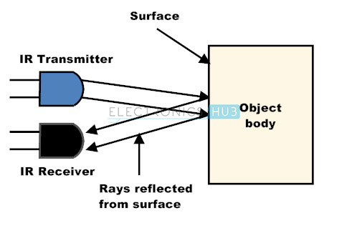
When the IR transmitter emits radiation, it reaches the object and some of the radiation reflects back to the IR receiver. Based on the intensity of the reception by the IR receiver, the output of the sensor is defined.

  - ARDUINO
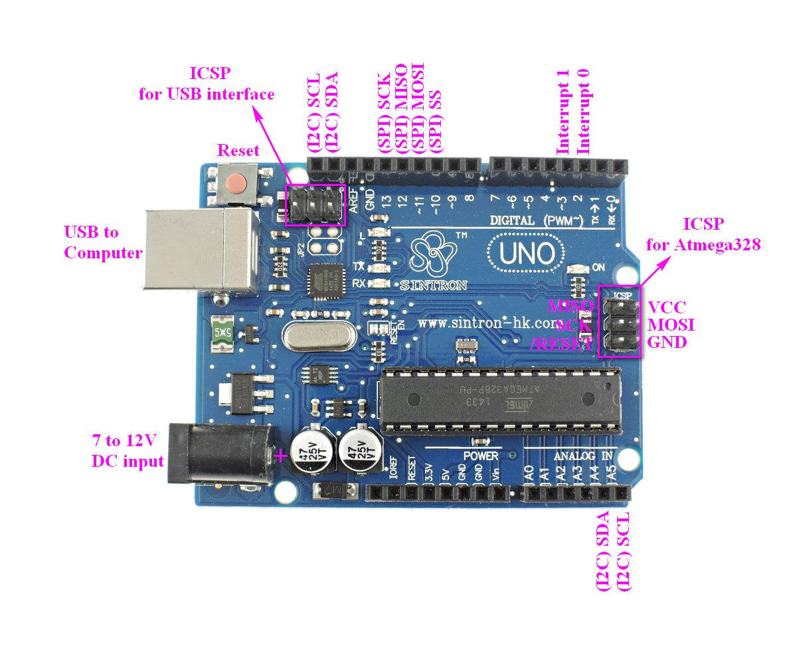
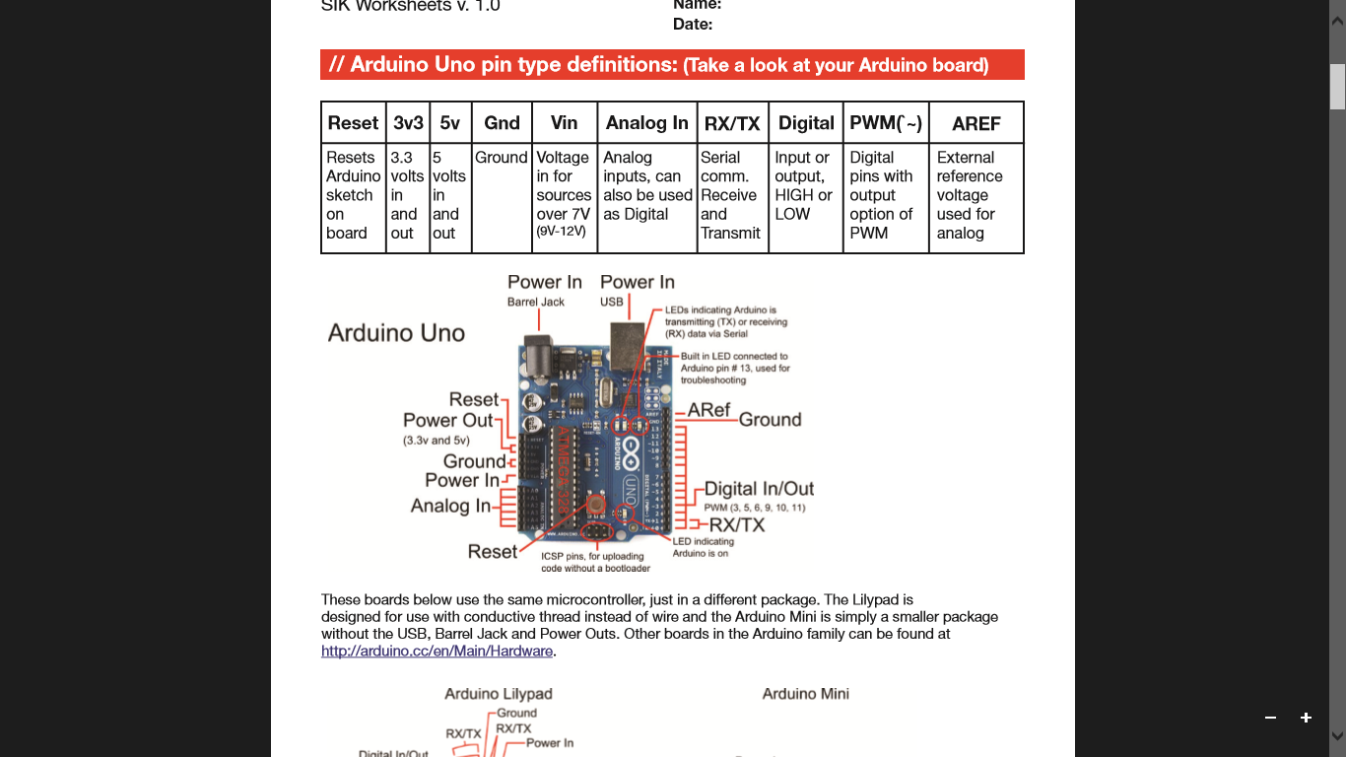
The Arduino Uno is a microcontroller board based on the ATmega328 (datasheet). It has 14 digital input/output pins (of which 6 can be used as PWM outputs), 6 analog inputs, a 16 MHz crystal oscillator, a USB connection, a power jack, an ICSP header, and a reset button. It contains everything needed to support the microcontroller; simply connect it to a computer with a USB cable or power it with a AC-to-DC adapter or battery to get started. The Uno differs from all preceding boards in that it does not use the FTDI USB-to-serial driver chip. Instead, it features the Atmega8U2 programmed as a USB-to-serial converter.

TECHNICAL SPESIFICATIONS:
- Microcontroller ATmega328.
- Operating Voltage 5V
- Input Voltage (recommended) 7-12V
- Input Voltage (limits) 6-20V
- Digital I/O Pins 14 (of which 6 provide PWM output)
- Analog Input Pins 6
- DC Current per I/O Pin 40 mA
- DC Current for 3.3V Pin 50 mA
- Flash Memory 32 KB of which 0.5 KB used by bootloader
- SRAM 2 KB
- EEPROM 1 KB
- Clock Speed 16 MHz

MEMORY:
The Atmega328 has 32 KB of flash memory for storing code (of which 0,5 KB is used for the bootloader); It has also 2 KB of SRAM and 1 KB of EEPROM (which can be read and written with the EEPROM library).
INPUT AND OUTPUT:
Each of the 14 digital pins on the Uno can be used as an input or output, using pinMode(), digitalWrite(), and digitalRead() functions. They operate at 5 volts. Each pin can provide or receive a maximum of 40 mA and has an internal pull-up resistor (disconnected by default) of 20-50 kOhms.
POWER TO ARDUINO:
The Arduino Uno can be powered via the USB connection or with an external power supply. The power source is selected automatically.
External (non-USB) power can come either from an AC-to-DC adapter (wall-wart) or battery. The adapter can be connected by plugging a 2.1mm center-positive plug into the board's power jack. Leads from a battery can be inserted in the Gnd and Vin pin headers of the POWER connector.
The board can operate on an external supply of 6 to 20 volts. If supplied with less than 7V, however, the 5V pin may supply less than five volts and the board may be unstable. If using more than 12V, the voltage regulator may overheat and damage the board. The recommended range is 7 to 12 volts.
The power pins are as follows:
• VIN. The input voltage to the Arduino board when it's using an external power source (as opposed to 5 volts from the USB connection or other regulated power source). You can supply voltage through this pin, or, if supplying voltage via the power jack, access it through this pin.
• 5V. The regulated power supply used to power the microcontroller and other components on the board. This can come either from VIN via an on-board regulator, or be supplied by USB or another regulated 5V supply.
• 3V3. A 3.3-volt supply generated by the on-board regulator. Maximum current draw is 50 mA.
• GND. Ground pin.

  - LED
A light Emitting Diode (LED) is an optical semiconductor device that emits light when voltageis applied. In other words, LED is an optical semiconductor device that converts electrical energy into light energy.
When Light Emitting Diode (LED) is forward biased, free electrons in the conduction band recombines with the holes in the valence band and releases energy in the form of light.
The process of emitting light in response to the strong electric field or flow of electric current is called electroluminescence. A normal p-n junction diode allows electric current only in one direction. It allows electric current when forward biased and does not allow electric current when reverse biased. Thus, normal p-n junction diode operates only in forward bias condition.
Like the normal p-n junction diodes, LEDs also operates only in forward bias condition. To create an LED, the n-type material should be connected to the negative terminal of the battery and p-type material should be connected to the positive terminal of the battery. In other words, the n-type material should be negatively charged and the p-type material should be positively charged.
The construction of LED is similar to the normal p-n junction diode except that gallium, phosphorus and arsenic materials are used for construction instead of silicon or germanium materials.
In normal p-n junction diodes, silicon is most widely used because it is less sensitive to the temperature. Also, it allows electric current efficiently without any damage. In some cases, germanium is used for constructing diodes.
However, silicon or germanium diodes do not emit energy in the form of light. Instead, they emit energy in the form of heat. Thus, silicon or germanium is not used for constructing LEDs.The symbol of LED is similar to the normal p-n junction diode except that it contains arrows pointing away from the diode indicating that light is being emitted by the diode.
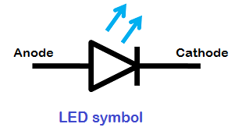

  - DC Motor
A motor is an electrical machine which converts electrical energy into mechanical energy. The principle of working of a DC motor is that "whenever a current carrying conductor is placed in a magnetic field, it experiences a mechanical force". The direction of this force is given by Fleming's left hand rule and it's magnitude is given by F = BIL. Where, B = magnetic flux density, I = current and L = length of the conductor within the magnetic field.
Fleming's left hand rule: If we stretch the first finger, second finger and thumb of our left hand to be perpendicular to each other AND direction of magnetic field is represented by the first finger, direction of the current is represented by second finger then the thumb represents the direction of the force experienced by the current carrying conductor.

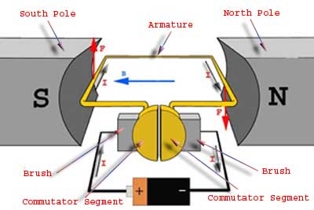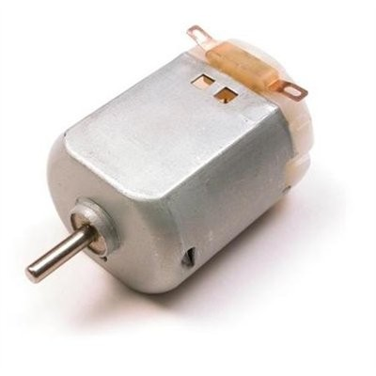

Above picture helps in understanding the working principle of a DC motor. When armature windings are connected to a DC supply, current sets up in the winding. Magnetic field may be provided by field winding (electromagnetism) or by using permanent magnets. In this case, current carrying armature conductors experience force due to the magnetic field, according to the principle stated above.
Commutator is made segmented to achieve unidirectional torque. Otherwise, the direction of force would have reversed every time when the direction of movement of conductor is reversed the magnetic field.

  - Breadboard
A breadboard is a rectangular plastic board with a bunch of tiny holes in it. These holes let you easily insert electronic components to prototype (meaning to build and test an early version of) an electronic circuit, like this one with a battery, switch, resistor, and an LED (light-emitting diode).
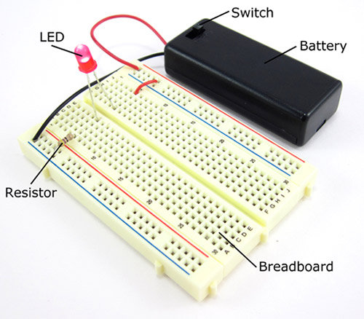Fig:9
The connections are not permanent, so it is easy to remove a component if you make a mistake, or just start over and do a new project. This makes breadboards great for beginners who are new to electronics. You can use breadboards to make all sorts of fun electronics projects, from different types of robots or an electronic drum set, to an electronic rain detector to help conserve water in a garden, just to name a few.

  - Jumper Wires
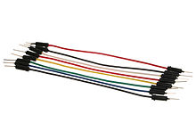
Stranded 22AWG jump wires with solid tips
Jump wires (also called jumper wires) for solderless breadboarding can be obtained in ready-to-use jump wire sets or can be manually manufactured. The latter can become tedious work for larger circuits. Ready-to-use jump wires come in different qualities, some even with tiny plugs attached to the wire ends. Jump wire material for ready-made or homemade wires should usually be 22 AWG (0.33 mm²) solid copper, tin-plated wire - assuming no tiny plugs are to be attached to the wire ends. The wire ends should be stripped ³⁄₁₆ to ⁵⁄₁₆ in (4.8 to 7.9 mm). Shorter stripped wires might result in bad contact with the board's spring clips (insulation being caught in the springs). Longer stripped wires increase the likelihood of short-circuits on the board. Needle-nose pliers and tweezers are helpful when inserting or removing wires, particularly on crowded boards.
Differently coloured wires and color-coding discipline are often adhered to for consistency. However, the number of available colours is typically far fewer than the number of signal types or paths. Typically, a few wire colours are reserved for the supply voltages and ground (e.g., red, blue, black), some are reserved for main signals, and the rest are simply used where convenient. Some ready-to-use jump wire sets use the colour to indicate the length of the wires, but these sets do not allow a meaningful color-coding schema.

  - Buzzer

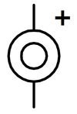
Electronic symbol for a buzzer
A buzzer or beeper is an audio signaling device, which may be mechanical, electromechanical, or piezoelectric. Typical uses of buzzers and beepers include alarm devices, timers, and confirmation of user input such as a mouse click or keystroke.
- CIRCUIT DIAGRAM & WORKING PRINCIPLE
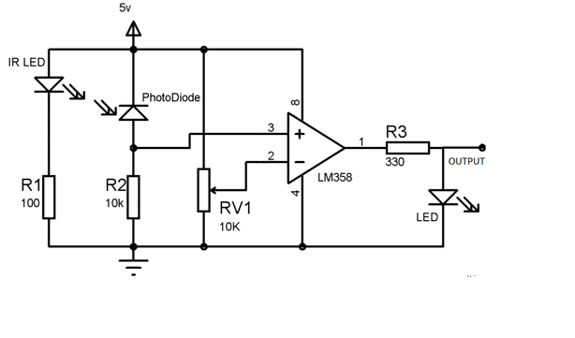
An IR sensor consists of an IR LED and an IR Photodiode; together they are called as Photo–Coupler or Opto–Coupler. As said before,the Infrared Obstacle Sensor has builtin IR transmitter and IR receiver. Infrared Transmitter is a light emitting diode (LED) which emits infrared radiations. Hence, they are called IR LED’s. Even though an IR LED looks like a normal LED, the radiation emitted by it is invisible to the human eye.
Infrared receivers are also called as infrared sensors as they detect the radiation from an IR transmitter. IR receivers come in the form of photodiodes and phototransistors. Infrared Photodiodes are different from normal photo diodes as they detect only infrared radiation. When the IR transmitter emits radiation, it reaches the object and some of the radiation reflects back to the IR receiver. Based on the intensity of the reception by the IR receiver, the output of the sensor is defined.

INTERFACING IR SENSOR WITH ARDUINO
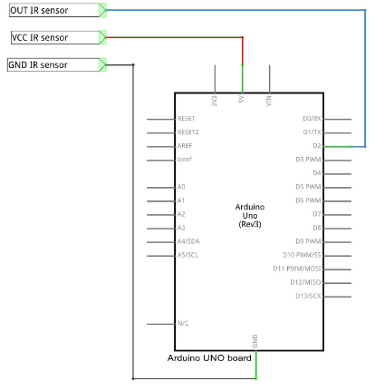

4. SOFTWARE USED IN PROJECT
  - EMBEDDED C
Embedded systems programming is different from developing applications on a desktop computers. Key characteristics of an embedded system, when compared to PCs, are as follows:
· Embedded devices have resource constraints (limited ROM, limited RAM, limited stack space, less processing power)
· Components used in embedded system and PCs are different; embedded systems typically uses smaller, less power consuming components. Embedded systems are more tied to the hardware.

Two salient features of Embedded Programming are code speed and code size. Code speed is governed by the processing power, timing constraints, whereas code size is governed by available program memory and use of programming language. Goal of embedded system programming is to get maximum features in minimum space and minimum time.

Embedded systems are programmed using different type of languages:
- Machine Code
- Low level language, i.e., assembly
- High level language like C, C++, Java, Ada, etc.
- Application level language like Visual Basic, scripts, Access, etc.

Assembly language maps mnemonic words with the binary machine codes that the processor uses to code the instructions. Assembly language seems to be an obvious choice for programming embedded devices. However, use of assembly language is restricted to developing efficient codes in terms of size and speed. Also, assembly codes lead to higher software development costs and code portability is not there. Developing small codes are not much of a problem, but large programs/projects become increasingly difficult to manage in assembly language. Finding good assembly programmers has also become difficult nowadays. Hence high level languages are preferred for embedded systems programming.

Use of C in embedded systems is driven by following advantages
- It is small and reasonably simpler to learn, understand, program and debug.
- C Compilers are available for almost all embedded devices in use today, and there is a large pool of experienced C programmers.
- Unlike assembly, C has advantage of processor-independence and is not specific to any microprocessor/ microcontroller or any system. This makes it convenient for a user to develop programs that can run on most of the systems.
- As C combines functionality of assembly language and features of high level languages, C is treated as a ‘middle-level computer language’ or ‘high level assembly language’
- It is fairly efficient
- It supports access to I/O and provides ease of management of large embedded projects.

Many of these advantages are offered by other languages also, but what sets C apart from others like Pascal, FORTRAN, etc. is the fact that it is a middle level language; it provides direct hardware control without sacrificing benefits of high level languages.

Compared to other high level languages, C offers more flexibility because C is relatively small, structured language; it supports low-level bit-wise data manipulation.

Compared to assembly language, C Code written is more reliable and scalable, more portable between different platforms (with some changes). Moreover, programs developed in C are much easier to understand, maintain and debug. Also, as they can be developed more quickly, codes written in C offers better productivity. C is based on the philosophy ‘programmers know what they are doing’; only the intentions are to be stated explicitly. It is easier to write good code in C & convert it to an efficient assembly code (using high quality compilers) rather than writing an efficient code in assembly itself. Benefits of assembly language programming over C are negligible when we compare the ease with which C programs are developed by programmers.

Objected oriented language, C++ is not apt for developing efficient programs in resource constrained environments like embedded devices. Virtual functions & exception handling of C++ are some specific features that are not efficient in terms of space and speed in embedded systems. Sometimes C++ is used only with very few features, very much as C.

Ada, also an object-oriented language, is different than C++. Originally designed by the U.S. DOD, it didn’t gain popularity despite being accepted as an international standard twice (Ada83 and Ada95). However, Ada language has many features that would simplify embedded software development.

Java is another language used for embedded systems programming. It primarily finds usage in high-end mobile phones as it offers portability across systems and is also useful for browsing applications. Java programs require Java Virtual Machine (JVM), which consume lot of resources. Hence it is not used for smaller embedded devices.

Dynamic C and B# are some proprietary languages which are also being used in embedded applications.

Efficient embedded C program must be kept small and efficient; they must be optimized for code speed and code size. Good understanding of processor architecture embedded C programming and debugging tools facilitate this.

  - PROGRAMMING
There is a two level programming in which embedded c is used in controlling the hardware which produces the distance and angle measurements using servo.

Hardware coding:
#define reading A0
#define buzzer 8
#define led 13
#define motor 7
void setup () {
// put your setup code here, to run once:

pinMode(reading,INPUT);
pinMode(buzzer,OUTPUT);
pinMode(led,OUTPUT);
pinMode(motor,OUTPUT);
Serial.begin(9600); //set the baud rate of the serial monitor
}
void loop() {// put your main code here, to run repeatedly:

digitalWrite (8, HIGH);
float value;
float distance;
value = analogRead(reading); //take reading from sensor
distance=value*0.00488;
if (distance < 4)/*if there's an obstacle 25 centimers, ahead, do the following: */
{
Serial.println ("Close Obstacle detected!" );
Serial.print (distance);
Serial.println (" The obstacle is declared a threat due to close distance. ");
Serial.println (" vehicle is stopping due to obstacle ");
digitalWrite (8, LOW);
delay (100);
digitalWrite (13, HIGH);
delay (10);

}
else {
Serial.println ("No obstacle detected. going forward");
digitalWrite (13, LOW);
delay (15);
digitalWrite (8, HIGH);

digitalWrite (7, LOW);
delay (15);
}
Serial.println(distance); //display value of voltage in serial monitor

delay (10);
}

  - APPLICATIONS
- Obstacle detection
- Surveillance
- On board installation of remote vehicles.
- Especially military applications
- This logic has been specially designed for vacuum cleaner. By using heavy rating motors ,strong mechanical structure and using highly sensitive obstacle sensors, it efficiently work as vacuum cleaner.
- It can be used in mines.
- They can be implemented in parking systems and in vehicles such as cars to avoid unwanted collisions.
- The growing need of usage of unmanned aerial vehicles in urban areas for especially military applications where it can be very useful in city wars.
- In robotics, obstacle avoidance is the task of satisfying some control objective subject to non-intersection or non-collision position constraints.

  - RESULT
S.No | Distance(cm) | Sensor detection
1 | 2 | Yes
2 | 5 | Yes
3 | 10 | Yes
4 | 15 | No

5. CONCLUSION
The prototype of the project concentrates on using IR sensor to detect the nearby obstacle/human/vehicle in the range of 10cm and made the LED, the BUZZER on and makes motor to stop.

